INVENTORY MANAGEMENT SYSTEM



**Submitted By:**

Muhammad Danial (233588)

Musa bin Abdullah (233576)

Abdullah Altaf (233558)

**Submitted To:**

Mamdam Atika Ali

Bs Computer Science (B)

**Department of Computer Science**Air University

Contents

1. EVALUATION............................................................................................................3
2. INTRODUCTION........................................................................................................5
3. OBJECTIVES..............................................................................................................7
4. FEATURES..................................................................................................................7
5. BUSINESS LOGIC......................................................................................................7
6. FLOW CHART............................................................................................................7
7. CLASS DIAGRAM.....................................................................................................7
8. IMPLEMENTATION..................................................................................................7
9. CONCLUSION AND RESULTS................................................................................7

### Chapter 1: EVALUATION TABLE

|  |  |  |  |  |  |  |
| --- | --- | --- | --- | --- | --- | --- |
| **Student Name** | **Roll No** | **Design (20%)** | **Functionality (30%)** | **Code Efficiency (20%)** | **Documentation & Presentation (30%)** | **Marks Obtained** |
| MUSA | 233576 |  |  |  |  |  |
| DANIAL | 233588 |  |  |  |  |  |
| ABDULLAH | 233558 |  |  |  |  |  |
|  |  |  |  |  |  |  |

1. Introduction 2.1 Overview of the Project
   * This project is an Inventory Management System built using C# and WPF. The system is designed to streamline inventory management processes by integrating functionalities such as authentication, customer management, product management, sales, invoicing, category and supplier management, and advanced site features like barcode generation and audit logs.

2.2 Problem Statement and Background

* Managing inventory is often a complex and error-prone process, especially for businesses dealing with large quantities of products and customers. Manual systems are inefficient and prone to human errors. This project aims to address these issues by providing an automated, user-friendly solution.

2.3 Significance of the Problem

* Automating inventory management reduces errors, saves time, and improves business efficiency. This system enables businesses to focus on growth while maintaining accurate records of sales, stock levels, and customer interactions.

1. Objectives 3.1 Primary Goals
   * Develop a robust, scalable, and secure inventory management system with a user-friendly interface.
   * Include all essential features like login, registration, customer and product management, and sales tracking.

3.2 Expected Outcomes

* A fully functional system capable of managing inventory efficiently, generating invoices, and tracking sales for individual customers. The system will also provide features like audit logs and barcode generation for enhanced functionality.

1. Features 4.1 Key Functionalities
   * Authentication: Login, Register, and Forgot Password pages.
   * Customer Management: Add, edit, delete, and view customer details.
   * Product Management: Manage product details, categories, and suppliers.
   * Sales Management: Record transactions and generate invoices.
   * Dashboard: Display sales data, stock levels, and customer activity.
   * Audit Logs: Track user actions and system events.
   * Barcode Generator: Create barcodes for products.

4.2 Innovative Aspects

* Advanced sales analytics for individual and overall sales tracking.
* Integrated barcode generation for seamless inventory management.
* Comprehensive audit log for user accountability.

1. Business Logic 5.1 Description of Core Logic
   * The system leverages a database to store and retrieve inventory, customer, and sales data. Core logic includes:
     + Authentication: Validating user credentials.
     + Inventory Management: Updating stock levels based on sales transactions.
     + Barcode Generation: Using libraries to generate unique barcodes for products.

5.2 Problem-Solving Approach

* Modular development to ensure scalability.
* Leveraging WPF for a responsive user interface and C# for efficient backend logic.
* SQL Server for reliable data storage.

1. Flow Chart 6.1 Application Flow Representation
   * Start → Login/Register → Dashboard → (Customer/Product/Sales Management) → Invoice Generation → Audit Logs → End

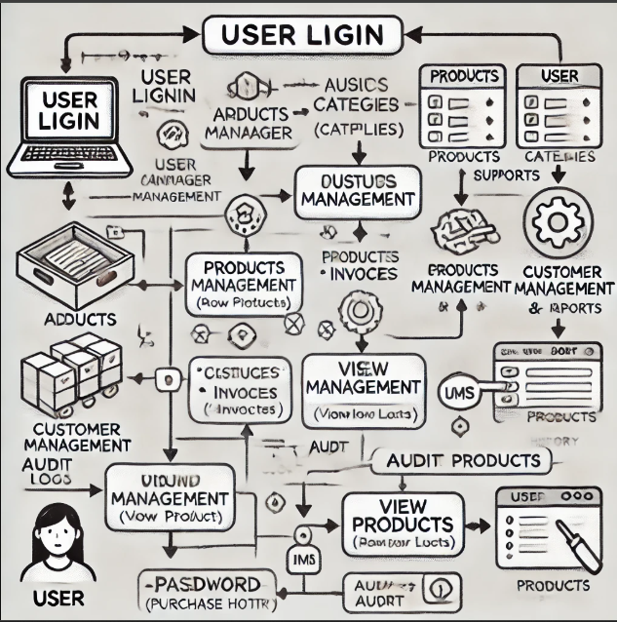

6.2 Annotations and Explanation

* The flowchart represents the sequence of operations, starting with user authentication and ending with generating audit logs for accountability.

1. Class Diagram 7.1 Overview of Class Structure
   * Key classes include User, Customer, Product, Supplier, Sale, and Invoice.
   * The class diagram details the system's architecture, showcasing the relationships between different classes and their roles in the IMS.

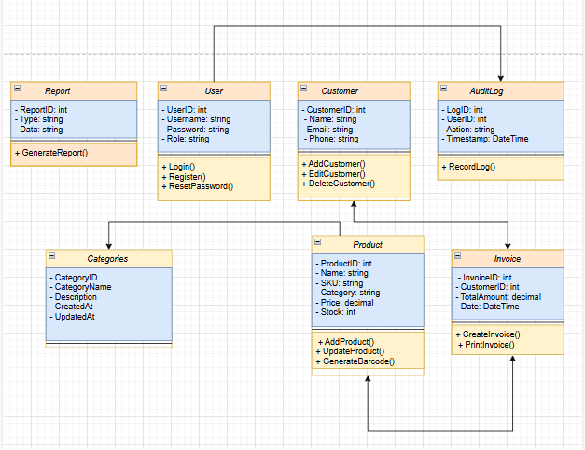

7.2 Class Relationships

* The Customer class is associated with Sale.
* The Product class is linked to both Category and Supplier.

7.3 Associations and Inheritance

* Classes inherit common properties from a BaseEntity class.

1. Implementation 8.1 Development Process
   * Agile methodology with iterative development cycles.
   * Development phases included requirement analysis, design, coding, testing, and deployment.

8.2 Screenshots of all User Interfaces

Screenshots include:

* THE CODE START WITH THE LOGIN PAGE WHERE WE CAN REGISTER AS SIGN UP OR COULD LOGIN FROM PRE-BUILT CODE SAVED IN DATA BASE.

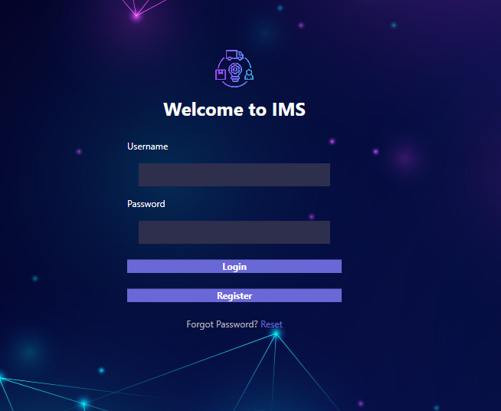

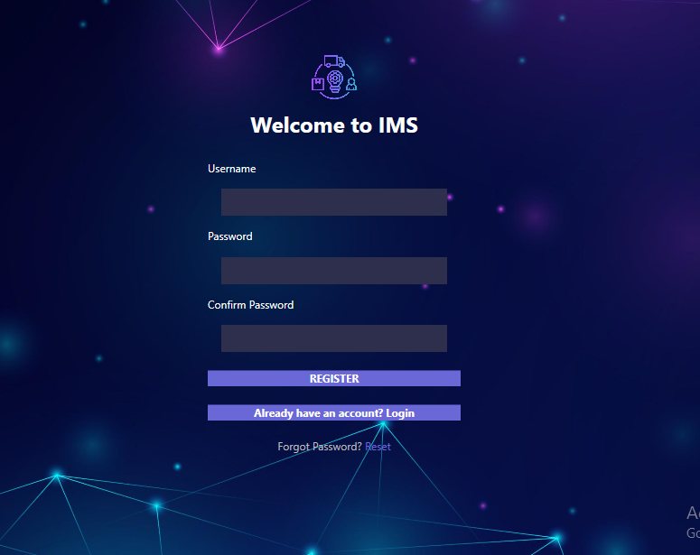

* AFTER LOGIN THE DASHBOARD APPEARS.

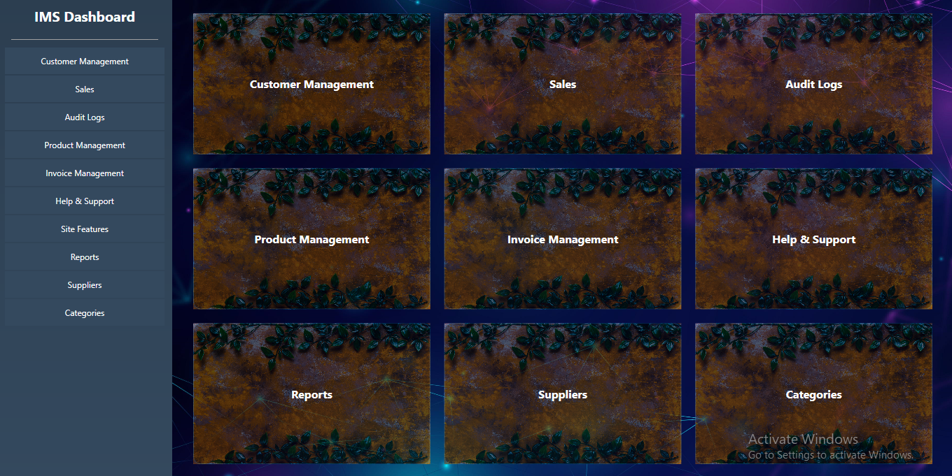

* CUSTOMER MANAGEMENT

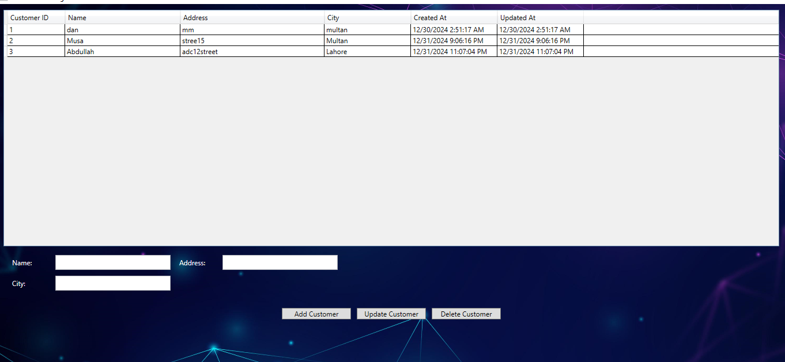

* SALES

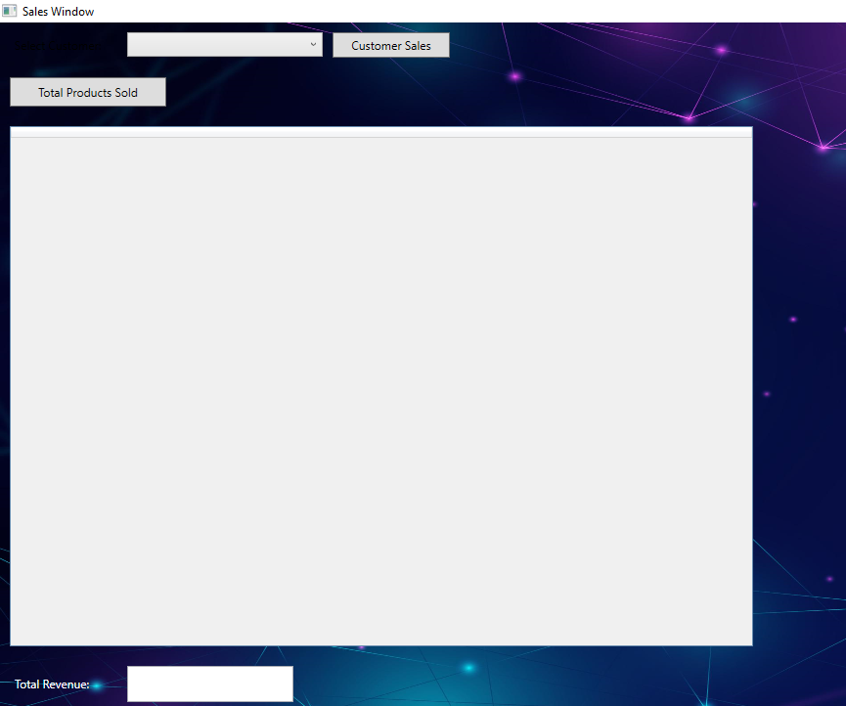

* AUDIT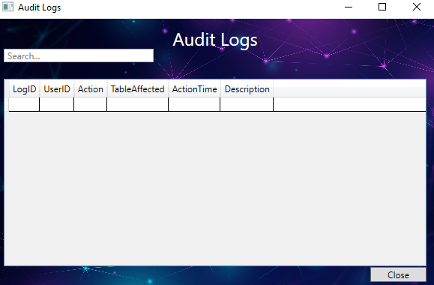
* PRODUCT MANAGEMENT 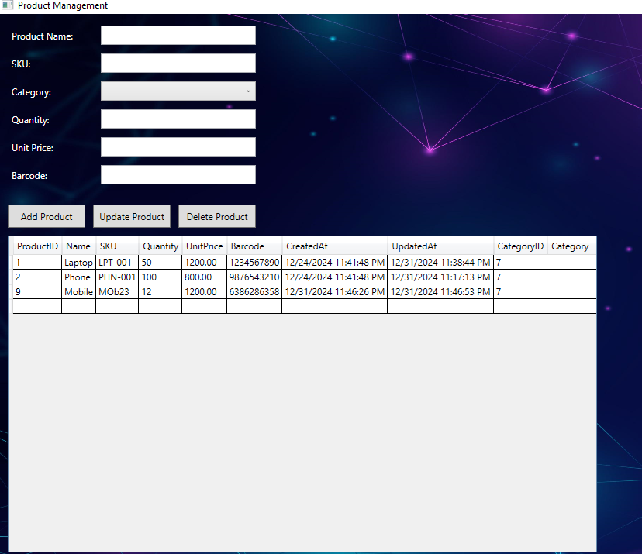
* INVOICE MANAGEMENT 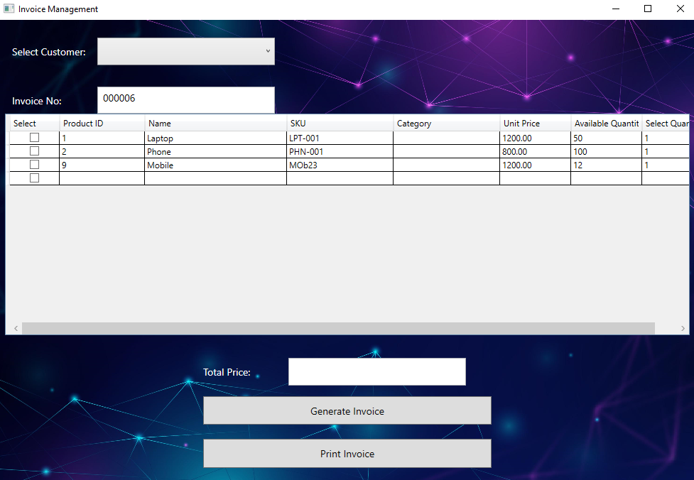
* HELP AND SUPPORT

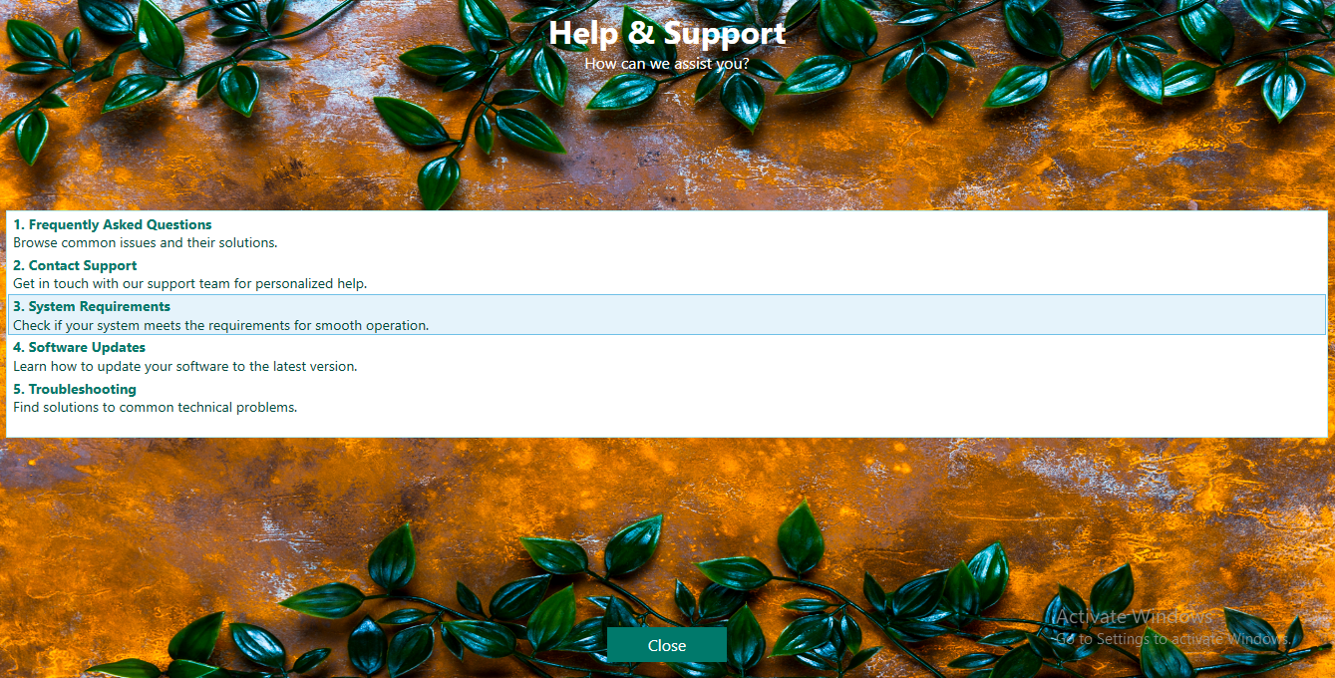

* REPORTS

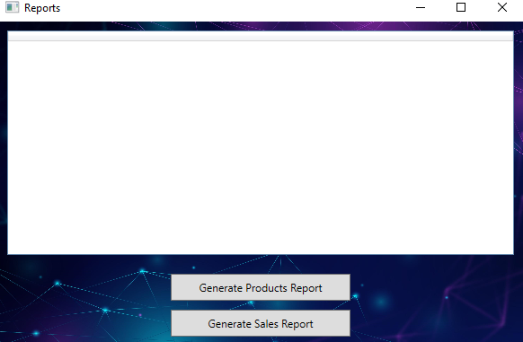

* SUPPLIERS

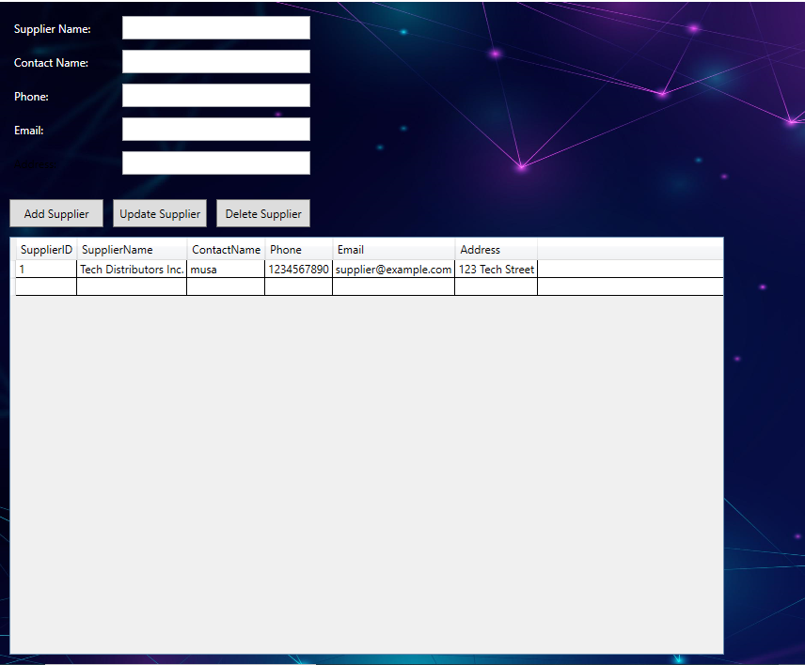

* CATAGORIES

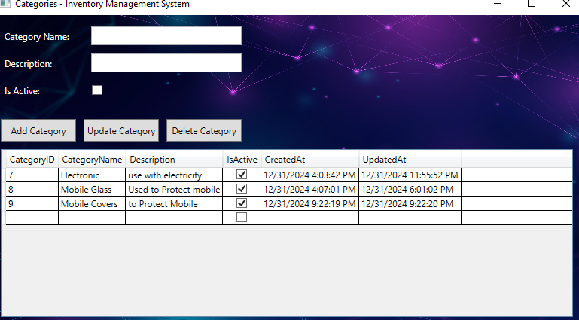

* Site Features

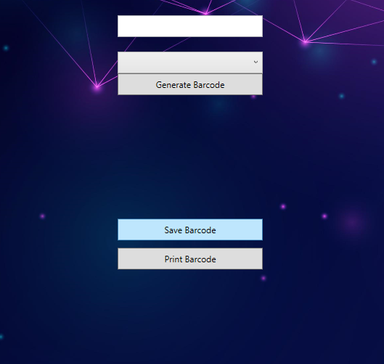

8.3 Tools and Technologies Used

* Programming Language: C#
* Framework: WPF (Windows Presentation Foundation)
* Database: SQL Server
* Development Environment: Visual Studio

8.4 Challenges and Solutions

* Challenge: Implementing real-time sales tracking.
  + Solution: Leveraged SQL Server triggers for real-time updates.
* Challenge: Ensuring security in authentication.
  + Solution: Used password hashing and secure database connections.

1. Conclusion and Results 9.1 Project Outcomes Summary
   * The project achieved its objectives by delivering a feature-rich inventory management system.

9.2 Comparison of Objectives and Results

* All primary goals were met, including user-friendly design and robust backend functionality.

9.3 Future Enhancements

* Adding mobile application support.
* Integrating machine learning for predictive analytics.
* Cloud-based deployment for enhanced accessibility.

1. References 10.1 Cited Resources

* Online tutorials, official C# and WPF documentation.

10.2 Further Reading

* Advanced topics in WPF and database optimization techniques.

1. Appendices 11.1 Additional Supporting Documents

* Database schema and design documents.

11.2 Code Snippets

* Database connection:

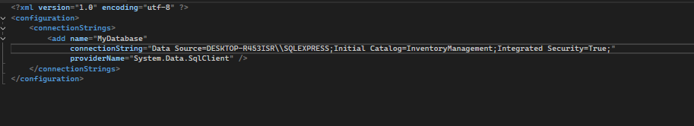

* Audit log: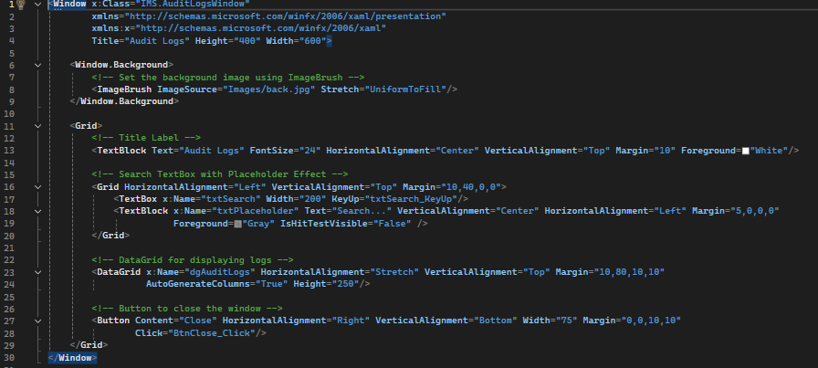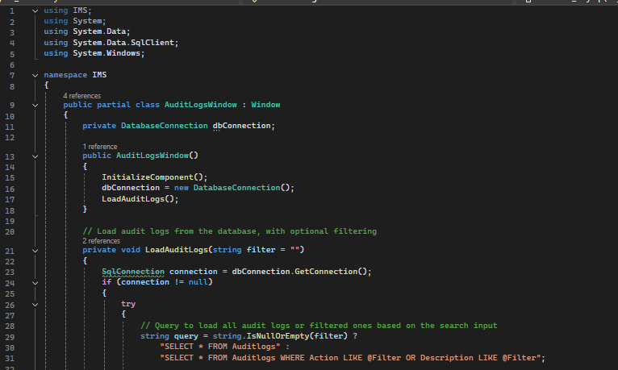
* Category:

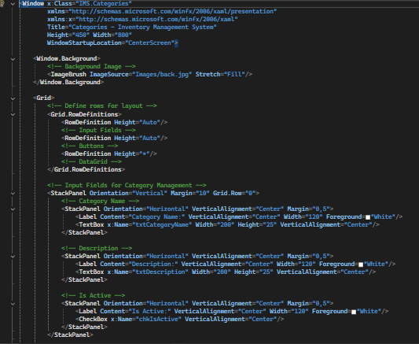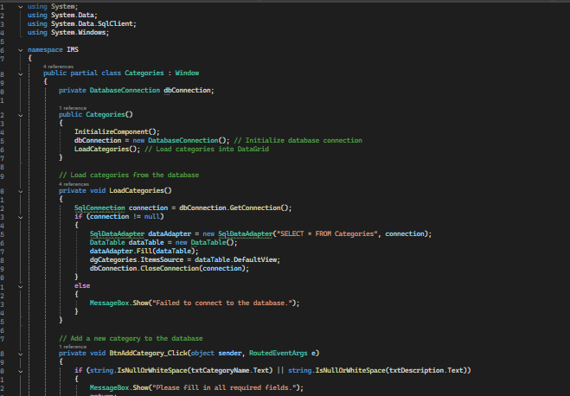

* Customer:

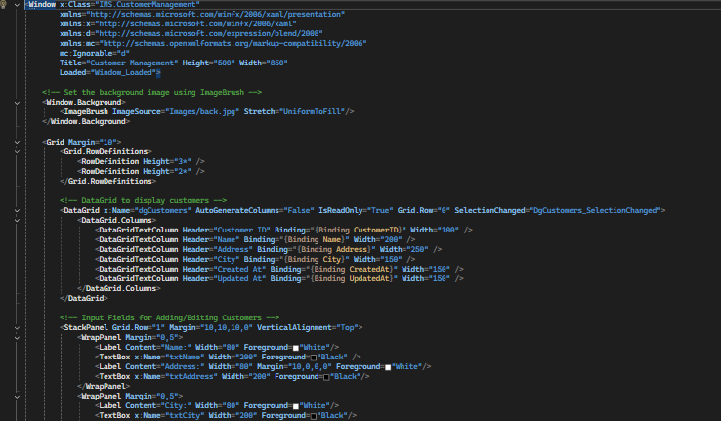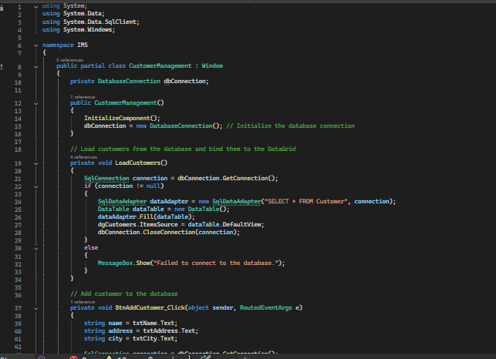

* Dashboard:

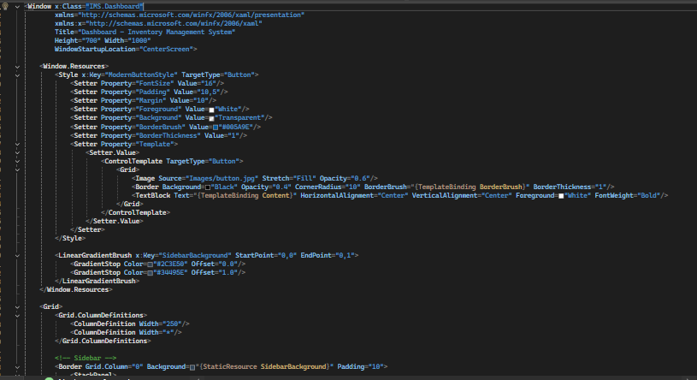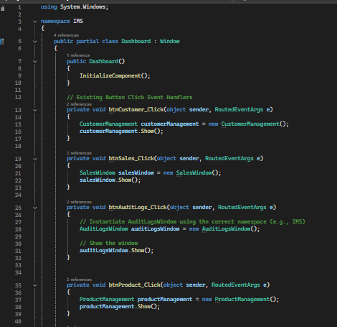

* Help and Support:

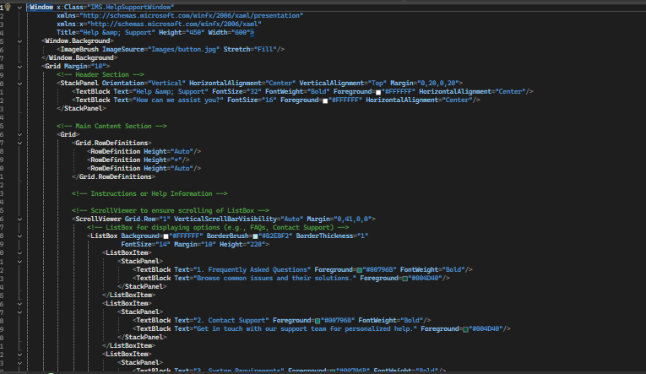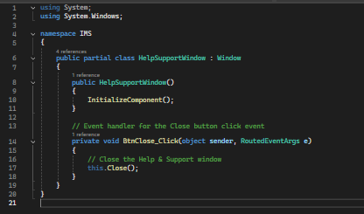

* Invoice:

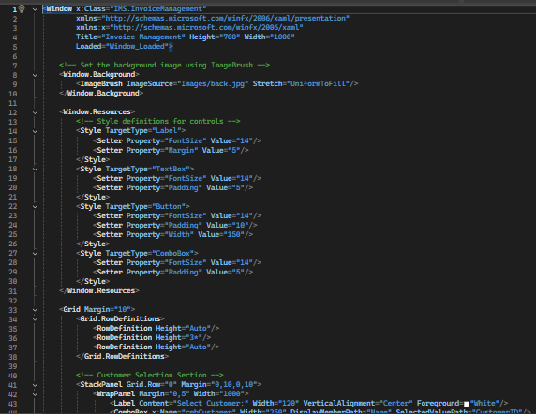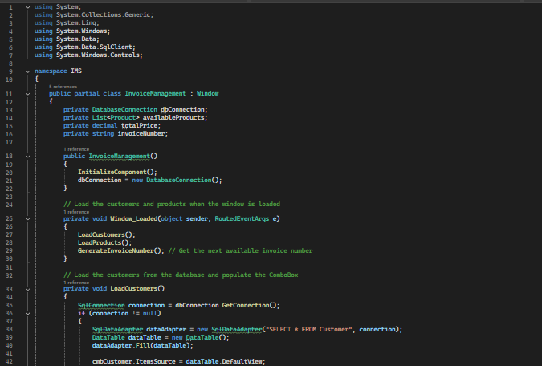

* Supplier

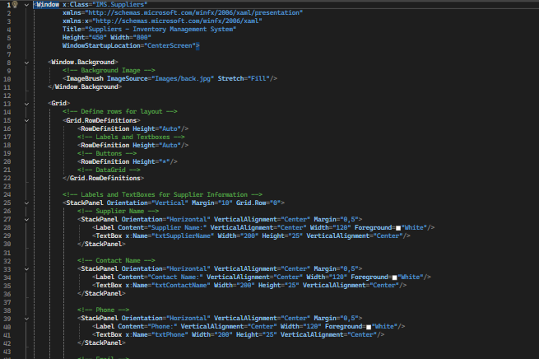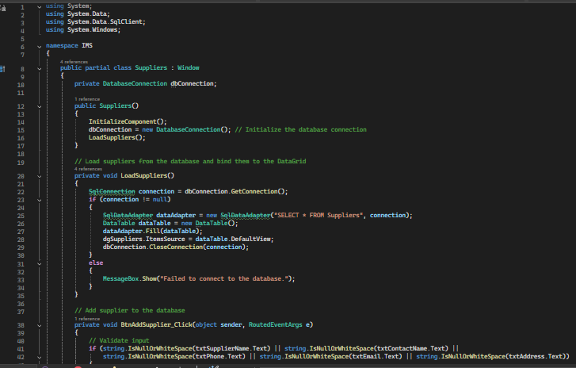

* Site Features:

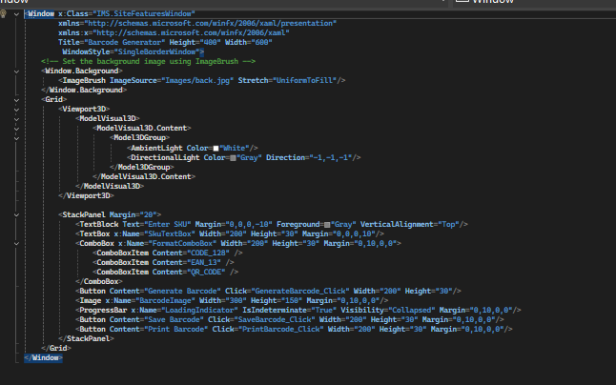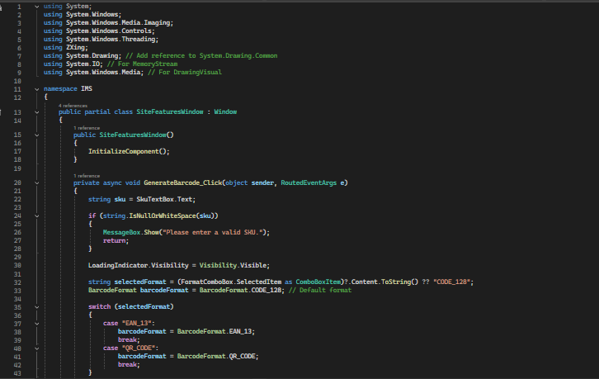

* Sales:

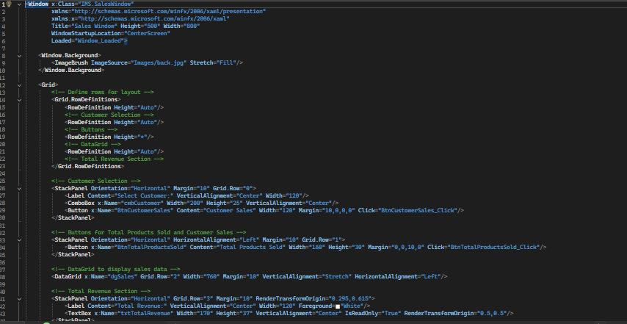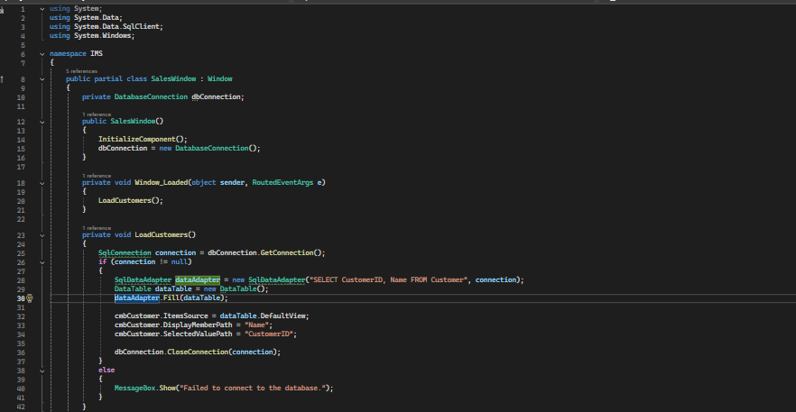

* Report:

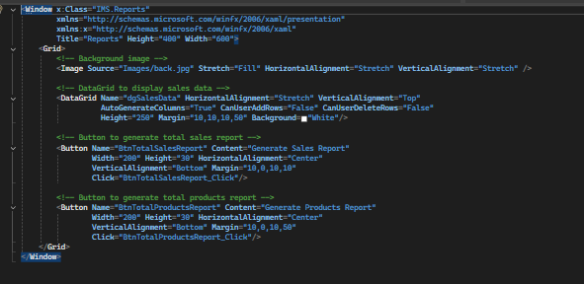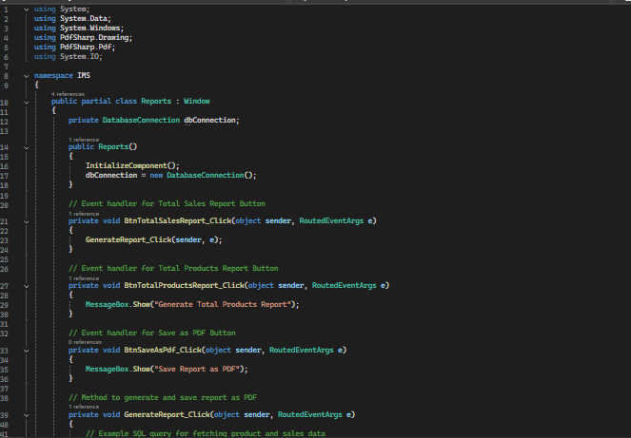

* Product:

